**MANUFACTURING TECHNOLOGY I**

***PROJECT BASED LEARNING***

**(Batch:-2021-2022)**

**Robotics and Automation (SEM IV)**

**TOPIC NAME:**

**GRAVITY LIGHT**

**Group Member Names:**

**Shivani Shinde**

**Rohit Patil**

**Rohit Sonawane**

**Jay Chavan**

**GUIDED BY**

**Dr. Pradeep D. Jadhav**

INDEX

CONTENTS PAGE NO:

Introduction to gravity light 01

Description of concept and its realisation 03

Newton’s law of gravitation 07

List of components required 08

Components discreption 10

Project module 20

Final project view 21

Advantages 22

Disadvantages 22

Applications 22

Conclusion 22

Gravity Light

INTRODUCTION

In recent times due to effects of pollution and global warming there is a need for generating power from renewable sources. The reason for generating power using gravity is that it is available all over the Earth, abundant and consistent too. In this project we designed a methodology wherein gravitational energy is further amplified in terms of its magnitude by using perpetual motion mechanism and hence can be successfully transformed into usable electrical energy. The basic concept of a gravity power generating mechanism is simple.

Perpetual motion describes "motion that continues indefinitely without any external source of energy impossible in practice because of friction. It can also be described as "the motion of a hypothetical machine which, once activated, would run forever unless subjected to an external force or to wear". There is a scientific consensus that perpetual motion in an isolated system would violate the first and/or second law of thermodynamics.

Cases of apparent perpetual motion can exist in nature, but either is not truly perpetual or cannot be used to do work without changing the nature of the motion. For example, the motion of a planet around its star may appear "perpetual," but interplanetary space is not completely frictionless, so planets' orbital motion is very gradually slowed over time. The fly-by of a space probe past a planet can be used to speed up the probe but in doing so alters the motion and reduces the energy of the planet in its orbit around the Sun. The flow of current in a superconducting loop can be used as an energy storage medium, but just as with a battery, using it to power a device will remove the equivalent amount of energy from the current in the loop.

Machines which extract energy from seemingly perpetual sources—such as ocean currents—are capable of moving "perpetually" (for as long as that energy source itself endures), but they are not considered to be perpetual motion machines because they are consuming energy from an external source and are not isolated systems (in reality, no system can ever be a fully isolated system). Similarly, machines which comply with both laws of thermodynamics but access energy from obscure sources are sometimes referred to as perpetual motion machines, although they also do not meet the standard criteria for the name.

Despite the fact that successful isolated system perpetual motion devices are physically impossible in terms of the current understanding of the laws of physics, the pursuit of perpetual motion remains popular.

There are many ways to convert gravitational energy into electrical energy. Gravia lamp is one of the mechanisms.

1.

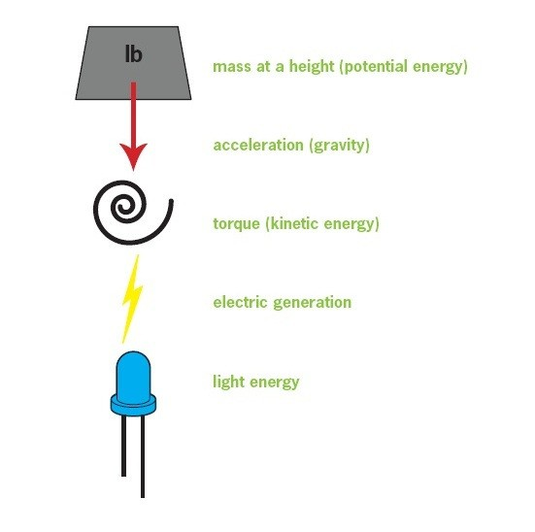. procedure for Power generation

When a body is at certain height from the ground, it possesses potential energy. Due to gravitational pull the body falls down. In this process, potential energy is converted to kinetic energy in the form of torque. And this converted into electrical energy using generator. The electrical energy is supplied to the LEDs, where electrical energy is converted into light energy. Gravialamp and Gravity Generator follows the same mechanism.

2.

Description of the Concept and its Realization

Problem/context:

Approximately 1/3 of the World's population is off-grid (having no access to mains power). This situation is not set to change in the near future, according to the World Bank and the World Health Organisation, and is identified as a major obstacle to the proliferation of education, and recognised as a limiting factor for growth in developing economies.

The vast proportion of existing solutions for heat and light in remote, off-grid, areas rely on bio-mass (carbon-based fuel sources). Concerns over ecological impact aside, a reliance on burning biomass for lighting (specifically oil) is expensive, keeping millions in fuel poverty, is unhealthy (producing toxic fumes and poor quality light) and dangerous (fire).

Initial Brief for 'Carbon-Free Kerosene Lamp' that led directly on to 'Gravity Light':

The charity Solar Aid identified kerosene (known in the UK as paraffin) as the predominant, bio-mass fuel source burned for lighting across developing African nations. They also identified some obstacles to the adoption of alternatives to kerosene that seemed to exist. Consequently, they formulated a brief for us to design a non-kerosene powered product that they felt would be more readily adopted by end users in these markets. This project was started in mid-2008.

They had observed that many individuals own traditional kerosene lamps and have usage patterns that are highly adapted to these devices, such as night fishermen who hang the robust, tin (and fragile glass) products on the end of long poles, erected at the prow of fishing boats. Solar-aid felt that if these kerosene lamp bodies could be adapted to run off a non-biomass power source, while maintaining familiar product semantics, consumer acceptance would be more widely, and quickly, achieved.

In addition to this, Solar Aid identified a price barrier, and suggested that any solution should have a maximum target retail price of around $6 USD to enable the average, low-wage, consumer to make a spontaneous purchase, as and when the opportunity arose, without the need to save-up. This was seen as key due to the lack of consumer credit mechanisms in their target markets.

Lastly, they felt that an additional benefit to the adaptation of existing kerosene lamps would be access to funding mechanisms within the carbon credits scheme for which they could qualify, where they hoped to

trade carbon credits through demonstrating quantities of converted lamps that no-longer relied on carbon-based fuel sources.

3.

Drawbacks/limitations of Solar Powered Devices:

Through an analysis of the production costs and bill of materials (BOM) of existing solar products, the cost of the chemical power storage (rechargeable batteries) was found to be proportionally high and fairly fixed. This raised concerns in the context of the target price: the rechargeable batteries typically constitute around 1/3 of the total combined production and BOM cost of micro solar products. These high-cost, chemical stores also have a short useful life, often as little as 18 months, before performance is significantly compromised. The chemicals employed are highly toxic, and at the end of life, there is a risk that they can be liberated into the local environment, polluting ground water and ending up in the food chain. The photo voltaic panels they employ are also relatively expensive to manufacture, although the trend has been for the cost of these to reduce significantly over time. Recharging the units requires a sunny day (not ubiquitous across the target countries), and some forward planning / logistical organisation is needed. Lastly, if the power runs out when the light is still required, there is no way to access more power until the sun reappears.

Drawback/limitations of Human Powered Devices:

Again, an analysis of the production costs and BOM of existing products was undertaken:

In existing products, where rechargeable batteries are employed, the same drawbacks as mentioned above exist. Where a spring is employed as an alternative energy store, for performance to be of an acceptable standard, a special type of spring that can deliver a constant force is required, and these springs are also expensive to manufacture. Constant force springs do not have the drawback of a short useful lifespan when employed correctly, but are limited by the quantity of power they can store in relation to their production cost. They also tend to be too large to fit within existing kerosene lamp bodies, and they tend to be heavy, decreasing portability and increasing transport costs. Human powered devices that employ hand-cranks (as the vast majority tend to) create high barriers to consumer acceptance due to the time investment required (it has been found that 3 or 4 minutes of user-winding for 45 minutes, or so, of useful light is not a time investment that consumers find attractive).

The length of this time investment is dictated by the rate of power going in to the device from the user's input, and the overall efficiency of the mechanical and chemical systems. The small muscle groups involved in winding a hand-crank suffer fatigue quickly, and the task is found to be repetitive and boring.

REVISED PROJECT OBJECTIVES - GRAVITY LIGHT:

The initial reasoning that led to Gravity Light can be summarised as follows. The Gravity Light study commenced later in 2008 on conclusion of the Solar aid project.

To address the problems and shortcomings of existing systems, putting all constraints in the original Solar-aid brief (apart from cost) to one side, could a system be developed to harvest and convert a short duration, human-powered input, to give a slow release, low-level power output, as and when it were needed?

If this could be achieved, we felt that we should be able to address the following drawbacks that exist with current solutions:

4.

Solar:

1. Sunshine is unreliable - sunshine would not be required
2. Storing power 'chemically' is expensive, resource hungry, and can be toxic when disposed of - no chemical store would be employed
3. Rechargeable batteries have a short life - solutions without rechargeable batteries have the potential for greatly increased life-spans
4. If the power runs out, no immediate recharge is available - a system could be 'recharged' as needed
5. Forward planning is required - power could be available as the need arises
6. Photo voltaic (PV) panels are expensive - no PV panels would be employed
7. Macro solar infrastructure is slow and expensive to proliferate - no infrastructure would be required

Human powered:

1. Drawbacks 2 and 3 above relating to batteries for Solar are common to many Human Powered devices
2. Time input from the user to charge is a barrier to adoption - time input could potentially be reduced by a factor of fifty (i.e. 1/50th of the user's time would be required)
3. Chemical power storage introduces efficiency losses (which matters when the user is required to crank a handle) - no chemical storage would be employed, thus such losses could be avoided
4. Constant force springs are expensive and heavy - no constant force spring would be used

TECHNOLOGICAL UNCERTAINTIES:

1. For the product proposal to make sense, in the context of departing from existing consumer behaviour patterns and experiences with a solution that would likely be quite novel, it would need to fully meet the very low (and ambitious) cost requirements of the target market to be attractive, otherwise it would run a high risk of failure / would not be viable.

5.

1. Successfully realising an innovative solution would require the product to communicate its purpose/function to the end user in an explicit way, while the end user may have no frame of reference from previous experience, and levels of literacy would be highly variable.
2. It was not clear at the outset how we could engineer proposals to meet the cost target or what technologies could be employed, if any existed.
3. We were aware that data did not exist to support some of the applications for components that we were considering, so an unknown amount of experimentation would be needed to build data around performance characteristics.
4. We were aware that meeting the cost targets could require a questioning/re-evaluation of all commonly applied methods of delivering the proposed functionality/efficiencies.
5. We anticipated that to achieve the short charge input and slow return of power, a very high ratio, low cost, step-up gearbox may be required, or a very innovative means of converting power would have to be identified/developed. Traditional step-up gearboxes can be very noisy and inefficient, even when engineered without tight cost constraints, and they are subject to efficiency losses. We would need to develop an approach that could be very low-cost, yet highly efficient.

At the outset, a wide range of potential avenues were explored. Information was gathered on the various technologies that could deliver light, in order to establish which ones would offer the greatest opportunities for the application. A wide range of technologies were considered, from conventional technologies, such as LED (Light Emitting Diode) and CFL (Compact Fluorescent) through to the much less conventional, such as bio-luminescence.

Armed with this information it was then possible to put some numbers next to potential lighting technologies in terms of production costs, efficiencies in use, brightness and projected lifespan. This confirmed LED as the most sensible light technology, scoring highest on all metrics.

Similarly, various means of storing power from short duration human powered inputs were investigated and brainstormed. The vast majority of this scoping and concept generation was undertaken in-house, but some of the concepts that arose, while looking at more unorthodox areas, required analysis beyond our in-house expertise. Consequently, we engaged with a consultancy: Intelligent Fluid Solutions, to help us explore, in quantitative terms, systems that might utilise pressurised liquid or gas mediums to store energy that could then be harnessed on slow release, with the potential benefit of minimised mechanical inefficiencies.

6.

Although some of the results from these pressure-store investigations looked highly promising, at least in theory, the practical realisation of them into physical devices embodied so many fundamental challenges, that other options were favoured.

We had also concluded, from our broader initial scoping, that to drive LED light sources, the wide availability of very low cost, high production volume DC motors offered potentially the lowest cost method of converting input energy into electric power, as conventional DC motors, when run in reverse via a torque input, will act as electric power generators.

Also with a view to minimising costs (this time in the distribution of any potential solution), the raising of a weight via a whole-body, short duration physical input, seemed like a very attractive and suitably low-tech approach, as mass is one of the few global resources that is practically unlimited, completely ubiquitous, and free. The weight could be sourced locally rather than shipped, and the human effort to lift it is renewable.

Initial consideration was given to what size and volume the weight should be. We felt it appropriate that any adult, or older child, should be able to charge the device, yet the larger the weight that was employed, the larger the energy reserve we would have to work with, so a compromise of 10kg was decided upon for the design weight, which would be reviewed and subject to trials.

In scoping out likely performance, some further numbers were needed next to important parameters. For these, a lift height of 9 feet was set (2.7m), as this is achievable by a short adult with arms raised above their head, and a drop time target of 30 minutes between lifts (charges) was set. These parameters were important in allowing us to estimate the potential power output of the system and to calculate the efficiencies that would need to be achieved.

With three main aspects defined: LED(s) as the light source, a DC motor as the generator, and the storage of input energy in potential form, the requirement for a highly efficient and low-cost step-up gearbox was indeed confirmed, as the DC motor would require a high speed input drive, and the raised weight must descend slowly in order for a charge to last for the target duration.

In considering how this high step-up ratio may be achieved, a key observation was made: a large ratio change can be obtained by rolling the edges of two plain metal wheels (or shafts), with greatly differing diameters, against each other. It was hypothesised that this could have the benefit of lower noise at high speeds when compared to conventional spur gears, and may not be susceptible to the energy losses and degradation normally associated with compliant material interfaces (such as rubber belt drives).

Newton’ law of universal gravitation :

Newton's law of universal gravitation states that any two bodies in the universe attract each other with a [force](https://en.wikipedia.org/wiki/Force) that is [directly proportional](https://en.wikipedia.org/wiki/Directly_proportional) to the product of their masses and [inversely proportional](https://en.wikipedia.org/wiki/Inversely_proportional) to the square of the distance between them.[[note 1]](https://en.wikipedia.org/wiki/Newton%27s_law_of_universal_gravitation#cite_note-2) This is a general [physical law](https://en.wikipedia.org/wiki/Physical_law) derived from [empirical](https://en.wikipedia.org/wiki/Empirical) [observations](https://en.wikipedia.org/wiki/Observation) by what [Isaac Newton](https://en.wikipedia.org/wiki/Isaac_Newton) called [induction](https://en.wikipedia.org/wiki/Inductive_reasoning).[[2]](https://en.wikipedia.org/wiki/Newton%27s_law_of_universal_gravitation#cite_note-3) It is a part of [classical mechanics](https://en.wikipedia.org/wiki/Classical_mechanics)and was formulated in Newton's work [Philosophiæ Naturalis Principia Mathematica](https://en.wikipedia.org/wiki/Philosophi%C3%A6_Naturalis_Principia_Mathematica" \o "Philosophiæ Naturalis Principia Mathematica) ("the Principia"), first published on 5 July 1687.

7.

(When Newton's book was presented in 1686 to the [Royal Society](https://en.wikipedia.org/wiki/Royal_Society), [Robert Hooke](https://en.wikipedia.org/wiki/Robert_Hooke) made a claim that Newton had obtained the inverse square law from him; see the [History](https://en.wikipedia.org/wiki/Newton%27s_law_of_universal_gravitation#History) section below.)

In modern language, the law states: Every [point](https://en.wikipedia.org/wiki/Point_mass) [mass](https://en.wikipedia.org/wiki/Mass) attracts every single other point mass by a [force](https://en.wikipedia.org/wiki/Force) pointing along the [line](https://en.wikipedia.org/wiki/Line_(mathematics)" \o "Line (mathematics))intersecting both points. The force is [proportional](https://en.wikipedia.org/wiki/Proportionality_(mathematics)) to the [product](https://en.wikipedia.org/wiki/Product_(mathematics)) of the two masses and [inversely proportional](https://en.wikipedia.org/wiki/Proportionality_(mathematics)#Inverse_proportionality) to the [square](https://en.wikipedia.org/wiki/Square_(algebra)) of the distance between them.[[3]](https://en.wikipedia.org/wiki/Newton%27s_law_of_universal_gravitation#cite_note-Newton1-4) The first test of Newton's theory of gravitation between masses in the laboratory was the [Cavendish experiment](https://en.wikipedia.org/wiki/Cavendish_experiment) conducted by the [British](https://en.wikipedia.org/wiki/United_Kingdom) scientist [Henry Cavendish](https://en.wikipedia.org/wiki/Henry_Cavendish) in 1798.[[4]](https://en.wikipedia.org/wiki/Newton%27s_law_of_universal_gravitation#cite_note-The_Michell-Cavendish_Experiment-5) It took place 111 years after the publication of Newton'sPrincipia and 71 years after his death.

Newton's law of gravitation resembles [Coulomb's law](https://en.wikipedia.org/wiki/Coulomb%27s_law) of electrical forces, which is used to calculate the magnitude of electrical force arising between two charged bodies. Both are [inverse-square laws](https://en.wikipedia.org/wiki/Inverse-square_law), where force is inversely proportional to the square of the distance between the bodies. Coulomb's law has the product of two charges in place of the product of the masses, and the[electrostatic constant](https://en.wikipedia.org/wiki/Electrostatic_constant) in place of the [gravitational constant](https://en.wikipedia.org/wiki/Gravitational_constant).

Newton's law has since been superseded by Einstein's theory of [general relativity](https://en.wikipedia.org/wiki/General_relativity), but it continues to be used as an excellent approximation of the effects of gravity in most applications. Relativity is required only when there is a need for extreme precision, or when dealing with very strong gravitational fields, such as those found near extremely massive and dense objects, or at very close distances (such as [Mercury](https://en.wikipedia.org/wiki/Mercury_(planet))'s orbit around the sun).

In modern language this law states:

|  |  |
| --- | --- |
| Every [point](https://en.wikipedia.org/wiki/Point_mass) [mass](https://en.wikipedia.org/wiki/Mass) attracts every single other point mass by a [force](https://en.wikipedia.org/wiki/Force) pointing alongthe [line](https://en.wikipedia.org/wiki/Line_(mathematics)) intersecting both points. The force is [proportional](https://en.wikipedia.org/wiki/Proportionality_(mathematics)) to the [product](https://en.wikipedia.org/wiki/Product_(mathematics)) of the two masses and [inversely proportional](https://en.wikipedia.org/wiki/Proportionality_(mathematics)#Inverse_proportionality) to the [square](https://en.wikipedia.org/wiki/Square_(algebra)) of the distance between them:[[3]](https://en.wikipedia.org/wiki/Newton%27s_law_of_universal_gravitation#cite_note-Newton1-4) | Diagram of two masses attracting one another |
| F = G \frac{m_1 m_2}{r^2}\  where:   * F is the force between the masses; * G is the [gravitational constant](https://en.wikipedia.org/wiki/Gravitational_constant) (6.674×10−11 N · (m/kg)2); * m1 is the first mass; * m2 is the second mass; * r is the distance between the centers of the masses. |

8.

Components required :

* Alternator(LOW RPM )/ Synochronous TD motor
* Gear
* Chain
* Weight
* Shaft
* Stand
* Clamp
* Plywood
* Nut-bolt
* Bridge rectifire
* Led bulb
* Conducting wire

9.

Component discreption:

1. Synochronous TD motor(low rpm):

Description : SS-5-240-TD AC 220/240V 4W 5 RPM,insulation class-B Turntable Synchronous Motor for Microwave Oven Low noise and environment protection A synchronous motor- with 2 pin terminals Geat for fan- warm air blower- electric heaters- burn oven- stage lighting equipment- microwave oven- and other kinds of electrical appliances Specification : Model : SS-5-240-TD Voltage : AC 220V/240V Frequency : 50Hz Power : 4W Speed : 5 RPM Overall Size : Approx. 6.5 x 6 x 3cm/2.56 x 2.37 x 1.18inch(LxWxT) Shaft Size : Approx. 7 x 10mm/0.28 x 0.40inch (DxL) Mount Hole Dia. : 4.1mm/ 0.161" Main material : Metal Color : As the pictures shown Package Included : 1 x Microwave Synchronous Motor Details pictures :

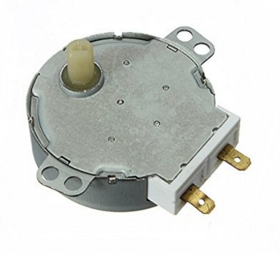

Gray Plastic Control Knobs :

Product Name : Microwave Oven Control Knob

Color : Gray

Material : Plastic

;Size(Approx) : 3.3 x 3 x 3cm / 1.3" x 1.2" x 1.2"(L\*W\*H)

Mounting Hole Diameter : 7.5mm/ 0.3"

Weight : 10g

10.

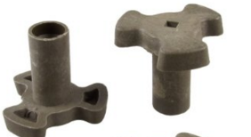

# Pic:  Gray Plastic Control Knobs

2.Gear arrangement:

A gear or cogwheel is a [rotating](https://en.wikipedia.org/wiki/Rotating) [machine](https://en.wikipedia.org/wiki/Machine_(mechanical)) part having cut teeth, or [cogs](https://en.wikipedia.org/wiki/Cog), which mesh with another toothed part to transmit [torque](https://en.wikipedia.org/wiki/Torque), in most cases with teeth on the one gear being of identical shape, and often also with that shape on the other gear. Two or more gears working in a sequence (train) are called a [gear train](https://en.wikipedia.org/wiki/Gear_train) or, in many cases, a [transmission](https://en.wikipedia.org/wiki/Transmission_(mechanics)); such gear arrangements can produce a [mechanical advantage](https://en.wikipedia.org/wiki/Mechanical_advantage) through a [gear ratio](https://en.wikipedia.org/wiki/Gear_ratio) and thus may be considered a [simple machine](https://en.wikipedia.org/wiki/Simple_machine). Geared devices can change the speed, torque, and direction of a [power source](https://en.wikipedia.org/wiki/Power_(physics)). The most common situation is for a gear to mesh with another gear; however, a gear can also mesh with a non-rotating toothed part, called a rack, thereby producing [translation](https://en.wikipedia.org/wiki/Translation_(physics)) instead of rotation.



11.

The gears in a transmission are analogous to the wheels in a crossed belt [pulley](https://en.wikipedia.org/wiki/Pulley) system. An advantage of gears is that the teeth of a gear prevent slippage.

When two gears mesh, and one gear is bigger than the other (even though the size of the teeth must match), a mechanical advantage is produced, with the [rotational speeds](https://en.wikipedia.org/wiki/Rotational_speed) and the torques of the two gears differing in an inverse relationship.

In transmissions with multiple gear ratios—such as bicycles, motorcycles, and cars—the term gear, as in first gear, refers to a gear ratio rather than an actual physical gear. The term describes similar devices, even when the gear ratio is [continuous](https://en.wiktionary.org/wiki/continuous) rather than [discrete](https://en.wiktionary.org/wiki/discrete), or when the device does not actually contain gears, as in a [continuously variable transmission](https://en.wikipedia.org/wiki/Continuously_variable_transmission).

3.Chain:

A bicycle chain is a [roller chain](https://en.wikipedia.org/wiki/Roller_chain) that transfers [power](https://en.wikipedia.org/wiki/Power_(physics)) from the [pedals](https://en.wikipedia.org/wiki/Bicycle_pedal) to the drive-[wheel](https://en.wikipedia.org/wiki/Bicycle_wheel) of a [bicycle](https://en.wikipedia.org/wiki/Bicycle), thus propelling it. Most bicycle chains are made from [plain carbon](https://en.wikipedia.org/wiki/Steel) or [alloy steel](https://en.wikipedia.org/wiki/Alloy_steel), but some are [nickel-plated](https://en.wikipedia.org/wiki/Nickel-plated) to prevent rust, or simply for aesthetics.A bicycle chain can be very energy efficient: one study reported efficiencies as high as 98.6%.The study, performed in a clean laboratory environment, found that efficiency was not greatly affected by the state of lubrication. A larger sprocket will give a more efficient drive, reducing the movement angle of the links. Higher chain tension was found to be more efficient: "This is actually not in the direction you'd expect, based simply on frictio.How best to [lubricate](https://en.wikipedia.org/wiki/Lubrication) a bicycle chain is a commonly debated question among cyclists. Liquid lubricants penetrate to the inside of the links and are not easily displaced, but quickly attract dirt. "Dry" lubricants, often containing [wax](https://en.wikipedia.org/wiki/Wax) or [Teflon](https://en.wikipedia.org/wiki/Polytetrafluoroethylene), are transported by an evaporating [solvent](https://en.wikipedia.org/wiki/Solvent), and stay cleaner in use. The cardinal rule for long chain life is never to lubricate a dirty chain, as this washes abrasive particles into the rollers. Chains should be cleaned before lubrication. The chain should be wiped dry after the lubricant has had enough time to penetrate the links. An alternative approach is to change the (relatively cheap) chain very frequently; then proper care is less important. Some [utility bicycles](https://en.wikipedia.org/wiki/Utility_bicycle) have fully enclosing [chain guards](https://en.wikipedia.org/wiki/Gear_case) which virtually eliminate chain wear and maintenance. On [recumbent bicycles](https://en.wikipedia.org/wiki/Recumbent_bicycle) the chain is often run through tubes to prevent it from picking up dirt, and to keep the cyclist's leg free from oil and dirt. The chain in use on modern bicycles has a 1/2" (=12.7 mm) [pitch](https://en.wikipedia.org/wiki/Pitch_(gear)#Pitch_nomenclature), which is [ANSI standard](https://en.wikipedia.org/wiki/Roller_chain#Chain_standards) #40, where the 4 in "#40" indicates the pitch of the chain in eighths of an inch, and metric #8, where the 8 indicates the pitch in sixteenths of an inch.Shimano did make their own 10 pitch system with 10 mm pitch from about 1970 to 1980[[11]](https://en.wikipedia.org/wiki/Bicycle_chain#cite_note-11) - called Shimano 10 pitch. The Shimano 10 pitch system is incompatible with ANSI standard #40 (1/2") e.g. chains, sprockets and so on. Chains come in either 3/32", 1/8", 5/32", or 3/16" roller widths, the internal width between the inner plates. 1/8" chains are used on bikes with a single rear sprocket: those with [coaster brakes](https://en.wikipedia.org/wiki/Bicycle_brake#Coaster_brakes), [hub gears](https://en.wikipedia.org/wiki/Hub_gear), [fixed gears](https://en.wikipedia.org/wiki/Fixed-gear_bicycle) such as [track bicycles](https://en.wikipedia.org/wiki/Track_bicycle), or [BMX](https://en.wikipedia.org/wiki/BMX) bikes. Chains with 3/32" wide rollers are used on bikes with [derailleurs](https://en.wikipedia.org/wiki/Derailleur) such as [racing](https://en.wikipedia.org/wiki/Racing_bicycle), [touring](https://en.wikipedia.org/wiki/Touring_bicycle), and [mountain bikes](https://en.wikipedia.org/wiki/Mountain_bike). Fixed sprockets and freewheels are also available in 3/32" widths so fixed-gear and[single-speed](https://en.wikipedia.org/wiki/Single-speed_bicycle) bikes can be set up to use narrow and lighter 3/32"

12.

chains. Finally, chains with 5/32" wide rollers are used on [freight bicycles](https://en.wikipedia.org/wiki/Freight_bicycle) and [tricycles](https://en.wikipedia.org/wiki/Tricycle" \o "Tricycle).With derailleur equipped bicycles, the external width of the chain also matters, because chains must not be too wide for the [cogset](https://en.wikipedia.org/wiki/Cogset" \o "Cogset) or they will rub on the next larger sprocket or too narrow that they might fall between two sprockets. Chains can also be identified by the number of rear sprockets they can support, anywhere from 3 to 11, and the list below enables measuring a chain of unknown origin to determine its suitability.Chains come in either 3/32", 1/8", 5/32", or 3/16" roller widths, the internal width between the inner plates. 1/8" chains are used on bikes with a single rear sprocket: those with [coaster brakes](https://en.wikipedia.org/wiki/Bicycle_brake#Coaster_brakes), [hub gears](https://en.wikipedia.org/wiki/Hub_gear), [fixed gears](https://en.wikipedia.org/wiki/Fixed-gear_bicycle) such as [track bicycles](https://en.wikipedia.org/wiki/Track_bicycle), or [BMX](https://en.wikipedia.org/wiki/BMX) bikes. Chains with 3/32" wide rollers are used on bikes with [derailleurs](https://en.wikipedia.org/wiki/Derailleur) such as [racing](https://en.wikipedia.org/wiki/Racing_bicycle), [touring](https://en.wikipedia.org/wiki/Touring_bicycle), and [mountain bikes](https://en.wikipedia.org/wiki/Mountain_bike).[[14]](https://en.wikipedia.org/wiki/Bicycle_chain#cite_note-14) Fixed sprockets and freewheels are also available in 3/32" widths so fixed-gear and[single-speed](https://en.wikipedia.org/wiki/Single-speed_bicycle) bikes can be set up to use narrow and lighter 3/32" chains. Finally, chains with 5/32" wide rollers are used on [freight bicycles](https://en.wikipedia.org/wiki/Freight_bicycle) and [tricycles](https://en.wikipedia.org/wiki/Tricycle" \o "Tricycle).With derailleur equipped bicycles, the external width of the chain also matters, because chains must not be too wide for the [cogset](https://en.wikipedia.org/wiki/Cogset" \o "Cogset) or they will rub on the next larger sprocket or too narrow that they might fall between two sprockets. Chains can also be identified by the number of rear sprockets they can support, anywhere from 3 to 11, and the list below enables measuring a chain of unknown origin to determine its suitability.

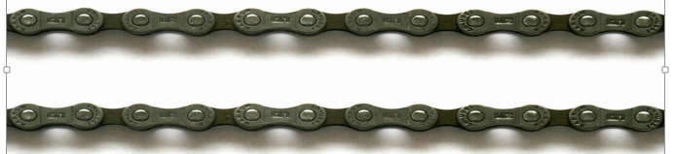

4.Weight:

In [science](https://en.wikipedia.org/wiki/Science) and [engineering](https://en.wikipedia.org/wiki/Engineering), the weight of an object is usually taken to be the [force](https://en.wikipedia.org/wiki/Force) on the object due to [gravity](https://en.wikipedia.org/wiki/Gravitation).[[1]](https://en.wikipedia.org/wiki/Weight#cite_note-Morrison-1)[[2]](https://en.wikipedia.org/wiki/Weight#cite_note-Galili-2) Weight is a[vector](https://en.wikipedia.org/wiki/Euclidean_vector) whose magnitude (a [scalar](https://en.wikipedia.org/wiki/Scalar_(physics)) quantity), often denoted by an italic letter W, is the product of the [mass](https://en.wikipedia.org/wiki/Mass) m of the object and the magnitude of the local [gravitational acceleration](https://en.wikipedia.org/wiki/Gravitational_acceleration) g;thus: W = mg. The [unit of measurement](https://en.wikipedia.org/wiki/Unit_of_measurement) for weight is that of [force](https://en.wikipedia.org/wiki/Force), which in the[International System of Units](https://en.wikipedia.org/wiki/International_System_of_Units) (SI) is the [newton](https://en.wikipedia.org/wiki/Newton_(unit)). For example, an object with a mass of one kilogram has a weight of about 9.8 newtons on the surface of the Earth, and about one-sixth as much on the [Moon](https://en.wikipedia.org/wiki/Moon). In this sense of weight, a body can be weightless only if it is far away (in principle infinitely far away) from any other mass. Although weight and mass are scientifically distinct quantities, the terms are often confused with each other in everyday use.

There is also a rival tradition within [Newtonian physics](https://en.wikipedia.org/wiki/Classical_mechanics) and engineering which sees weight as that which is measured when one uses scales. There the weight is a measure of the magnitude of the reaction force exerted on a body. Typically, in measuring an object's weight, the object is placed on scales at rest with respect to the earth, but the definition can be extended to other states of motion. Thus, in a state of free fall, the weight would be zero. In this second sense of weight, terrestrial objects can be weightless. Ignoring[air resistance](https://en.wikipedia.org/wiki/Drag_(physics)), the

13.

famous apple falling from the tree, on its way to meet the ground near [Isaac Newton](https://en.wikipedia.org/wiki/Isaac_Newton), is weightless.

Further complications in elucidating the various concepts of weight have to do with the [theory of relativity](https://en.wikipedia.org/wiki/Theory_of_relativity) according to which gravity is modelled as a consequence of the [curvature](https://en.wikipedia.org/wiki/Curvature) of [spacetime](https://en.wikipedia.org/wiki/Spacetime). In the teaching community, a considerable debate has existed for over half a century on how to define weight for their students. The current situation is that a multiple set of concepts co-exist and find use in their various contexts.

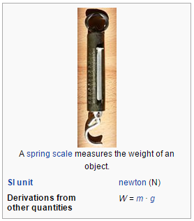

5.Shaft:

A **drive shaft**, **driveshaft**, **driving shaft**, **propeller shaft** (**prop shaft**), or **Cardan shaft** is a mechanical component for transmitting [torque](https://en.wikipedia.org/wiki/Torque) and rotation, usually used to connect other components of a [drive train](https://en.wikipedia.org/wiki/Drive_train) that cannot be connected directly because of distance or the need to allow for relative movement between them.As torque carriers, drive shafts are subject to [torsion](https://en.wikipedia.org/wiki/Torsion_(mechanics)) and [shear stress](https://en.wikipedia.org/wiki/Shear_stress), equivalent to the difference between the input torque and the load. They must therefore be strong enough to bear the stress, whilst avoiding too much additional weight as that would in turn increase their [inertia](https://en.wikipedia.org/wiki/Inertia" \o "Inertia).To allow for variations in the alignment and distance between the driving and driven components, drive shafts frequently incorporate one or more [universal joints](https://en.wikipedia.org/wiki/Universal_joint), [jaw couplings](https://en.wikipedia.org/wiki/Jaw_coupling), or [rag joints](https://en.wikipedia.org/wiki/Rag_joint), and sometimes a [splined joint](https://en.wikipedia.org/wiki/Rotating_spline) or [prismatic joint](https://en.wikipedia.org/wiki/Prismatic_joint). 14.

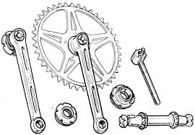

6.Stand:we have made stand for holding plywood & component at height 10feet by using iron pipe.and their view is as

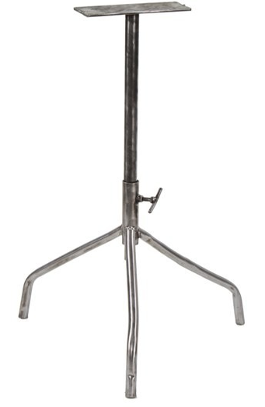

7.Clamp:we have used five clamp made of iron strip in which four has been used for the perpus of rim fitting with plywood and one has been used for the stand fitting.

15.

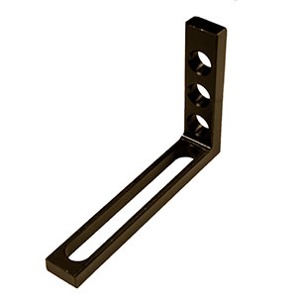

8.Plywood:we have used plywood for the perpus of component mounting.The size of plywood is 5\*2 feet.

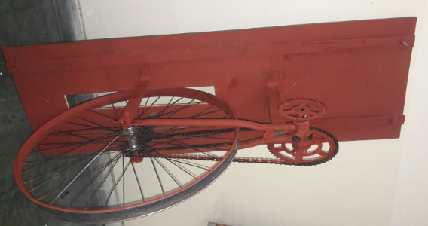

16.

9.Nut-bolt:

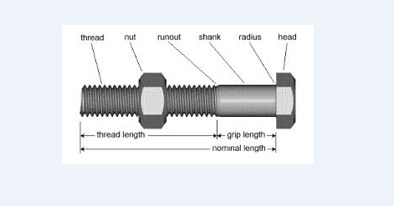Few parts are as critical in the assembly of modern machinery as the nuts and bolts which hold it all together and, at first sight, it seems that all metric bolt sare basically the same.

In fact, of course, nothing could be further from the truth. There are no fewer than 5 different threads for different applications and 10 different standard strength grades defined for each size of bolt. There are nineteen standard sizes - known as the ‘preferred’ sizes and ten less commonly used (the so called ‘non-preferred’) sizes. The situation is almost as complex with metric nuts which come in a wide variety of types (full, thin, nyiloc, castellated.....) and 5 strength grades as well as the same range of sizes. The difference in strength between different grades is quite dramac: the highest standard grade being capable of carrying more than three 􀆟 mesas much load as the lowest grade. If you are responsible for repairing and maintaining machinery, particularly if that machinery is involved in liting operations or other safety critical applications then you will be aware of the importance of fi 􀆫 ng the right parts in the right way. This short guide is intended to give you the information you need to be able to correctly identify and use the metric nuts and bolts most commonly found in plant and machinery.

10.Rectifire:

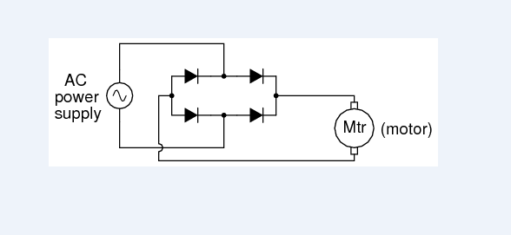

In the last classes we have seen the equivalent circuit of the diode. Today we will be discussing about the rectifier circuit which is an important application of semiconductor diode. Basically what is a rectifier? The rectifier circuit is a circuit which rectifies AC voltage into DC voltage. In most electronic applications we will be requiring DC voltage that it constant voltage supply. In order to get constant DC voltage from the supplied AC voltage because in our homes we get AC supply that is we get alternating current and so in order to get DC voltage level from AC we will have to use rectifier circuit where diode is used. The DC

17

power supply has different stages. Starting from an AC supply it will be using a transformer to bring it to the desired level of AC voltage and then rectifier circuit to rectify the AC into unipolar voltage and then there will be filtering circuit to smoothen out the pulsating DC voltage which we get after rectification and then another regulator circuit will be there to finally keep it at a constant voltage level.

11.Ledbulb:

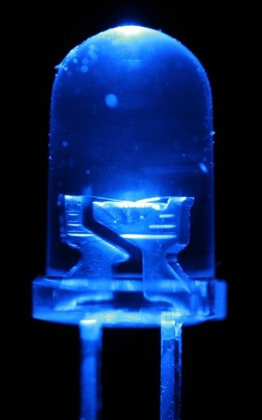

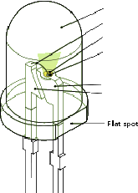

A light-emitting diode (LED) is a semiconductor light source. LEDs are used as indicator lamps in many devices and are increasingly used for other lighting. Appearing as practical electronic components in 1962, early LEDs emitted low- intensity red light, but modern versions are available across the visible, ultraviolet, and infrared wavelengths, with very high brightness. When a light-emitting diode is switched on, electrons are able to recombine with holes with in the device, releasing energy in the form of photons. This effect is called electroluminescence and the colour of the light (corresponding to the energy of the photon) is determined by the energy band gap of the semiconductor. An LED is often small in area (less than 1 mm2), and integrated optical components may be used to shape its radiation pattern. LEDs present many advantages over incandescent light sources including lower energy consumption, longer lifetime, improved physical robustness, smaller size, and faster switching. However, LEDs powerful enough for room lighting are relatively expensive and require more precise current and heat management than compact fluorescent lamp sources of comparable output.

Light-emitting diodes are used in applications as diverse as aviation lighting, automotive lighting, advertising, general lighting, and traffic signals. LEDs have allowed new text, video displays, and sensors to be developed, while their high switching rates are also useful in advanced communications technology. Infrared LEDs are also used in the remote control units of many commercial products including televisions, DVD players and other domestic appliances. LEDs are also used in seven- segment display.

18

The LED consists of a chip of semiconducting material doped with impurities to create a p-n junction. As in other diodes, current flows easily from the p-side, or anode, to the n-side, or cathode, but not it the reverse direction. Charge-carriers—electrons and holes—flow into the junction from electrodes with different voltages. When an electron meets a hole, it falls into a lower energy level, and releases energy in the form of a photon.

The wavelength of the light emitted, and thus its colour depends on the band gap energy of the materials forming the p-n junction. In silicon or germanium diodes, the electrons and holes recombine by a non-radiative transition, which produces no optical emission, because these are indirect band gap materials. The materials used for the LED have a direct band gap with energies corresponding to near-infrared, visible, or near-ultraviolet light.

LED development began with infrared and red devices made with gallium arsenide. Advances in materials science have enabled making devices with ever-shorter wavelengths, emitting light in a variety of colours. LEDs are usually built on an n-type substrate, with an electrode attached to the p-type layer deposited on its surface. P-type substrates, while less common, occur as well. Many commercial LEDs, especially GaN/InGaN, also use sapphire substrate.

Most materials used for LED production have very high refractive indices. This means that much light will be reflected back into the material at the material/air surface interface. Thus, light extraction in LEDs is an important aspect of LED production, subject to much research and development.

12.Conducting wire:

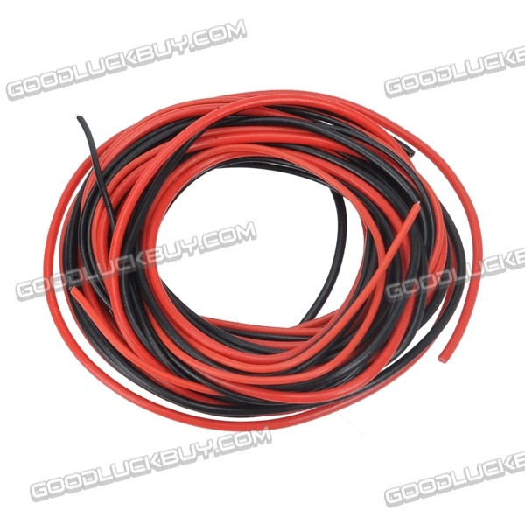

19.

PROJECT MODULE:

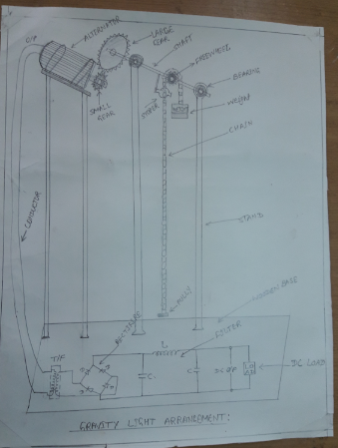

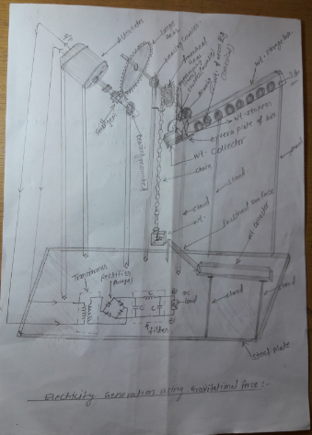

20.

FINAL PROJECT VIEW:

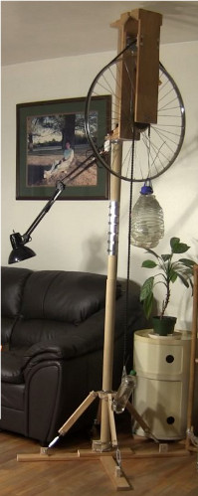

21.

ADVANTAGES:  Gravity Light converts gravitational energy into light, just like its name promises. That's right, you lift a bag filled with 20 pounds of stuff (sand, earth, whatever) and attach it to a cord. As gravity pulls the bag down, an LED light is illuminated, working kind of like those hand-cranked flashlights. A braking mechanism causes the weight to drop slowly, producing about 30 minutes of light, and returning the bag to its original height "restarts" the light.

For the last four years, the project has been aimed at a way to replace kerosene lamps used in certain parts of the world still. The designers eventually produced a working prototype and then turned to Indiegogo to get it up to production level.

DISADVANTAGES: This sustainable lighting device was conceived as a way to generate **electric light** in developing countries where the lack of electrical infrastructure requires fossil fuels to be used as an energy source. But these lamps, which are generally powered by kerosene, generate a high degree of pollution and pose a high risk of accidents due to their flammability. These disadvantages make these lighting systems dangerous and environmentally unsustainable.

APPLICATIONS: **Gravity Light** is a [gravity-powered lamp](https://en.wikipedia.org/wiki/Mechanically_powered_flashlight) designed by the company Deciwatt for use in [developing](https://en.wikipedia.org/wiki/Developing) or [third-world](https://en.wikipedia.org/wiki/Third-world) nations, as a replacement for [kerosene lamps](https://en.wikipedia.org/wiki/Kerosene_lamp). It uses a bag filled with rocks or earth, attached to a cord, which slowly descends similar to the weight drive in auto clock. This action powers the light for up to thirty minutes

CONCLUSION:

When compared to other sources of energy like hydal, thermal, tidal, wind, nuclear etc. Gravity is more abundant and available everywhere on the earth. Moreover it is eco-friendly. The output of the equipment depends on specifications of the generator, disk, electric circuit, battery. So, by increasing the specifications of the components we can improve the power output. The applications of this project are:

• Appliances like flash lights, radios, lanterns, torches, calculators, watches and cameras with low voltage ranging between 1.2 -9V can be powered.

• Cell phone batteries oscillating between 3.6 – 4.2V can be charged.

• Toys with batteries’ voltage ranging between 1.2 – 9V can be power.

• Alkaline and Zn-C batteries that require 1.5V are charged.

• NiCd and NiMH with voltage 1.2V are charged.

• Li cells of 3V can be charge

22.